**SOFTWARE DESIGN DOCUMENTATION**

**AIRPORT MANAGEMENT SYSTEM**

**1.INTRODUCTION**

**1.1 PURPOSE**

The purpose of this document is to describe the Airport Management System. It contains the functional, behavioural and non- functional requirements of the project and contains guidelines for system engineers and designers to start working on this project.

**1.2 SCOPE**

The airport management system is basically an all-in-one mobile application for your complete flight experience, from home to the airport. It enables the users to get details regarding the timings of their flight, the boarding gate, traffic conditions from their residence to the airport, to call for assistance and also regarding the in-airport amenities such as restaurants, shopping centres etc.

**1.3 OVERVIEW**

This section provides a description of the project from a management perspective and an overview of the framework within which the conceptual system design was prepared. It provides a high level system architecture, showing a subsystem breakout of the system. It shows the interfaces to the external systems.

**2. SYSTEM OVERVIEW**

This system functions on 2 levels :

1. For passengers : It enables the passengers to access all the required information about their flight in one go. The passengers can login into their accounts using any mobile device, provided it has an active internet connection and has this application installed.
2. For Administrators : The administrators can input and edit information about the flights, the airport and the amenities available at the airport. A 2-step authorisation is required to log into the administrator’s account.

**3. SYSTEM ARCHITECTURE**

**3.1 ARCHITECTURAL DESIGN**

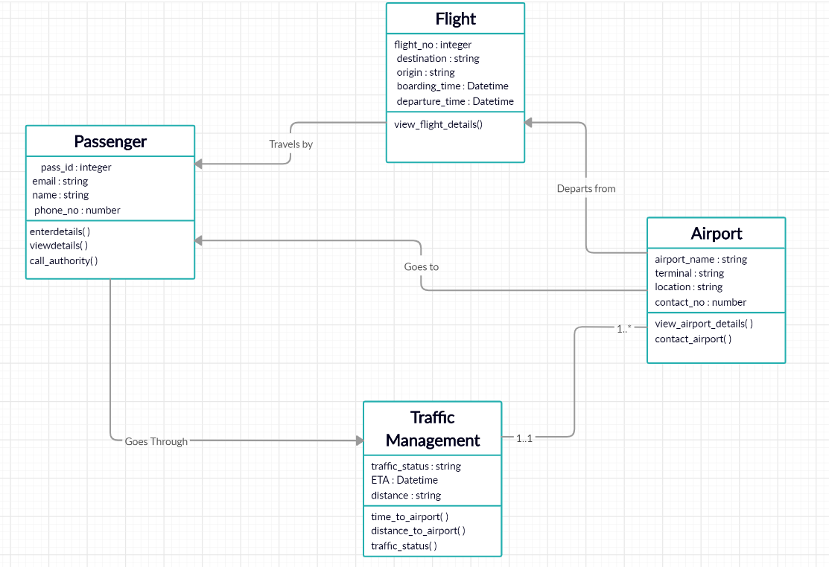

**3.2 DECOMPOSITION DESCRIPTION**

The system is decomposed into 4 modules, which have the following functions:

1. PASSENGER : This module represents the passengers travelling by the flights. The associated functions are:

* Enterdetails(): this function is used to get the details of a passenger ie. Name, email, contact number etc.
* Viewdetails(): This function is used to display all the details of a given passenger.
* Call_authority(): This function is used to contact the authorities of a particular airport in case of emergencies.

1. FLIGHT : This module represents the flights departing from the airport. The associated functions are:

* Enter_flight_details(): this function is used to get the details of the flight ie. Flight number, destination, origin, boarding time etc.
* View_flight_details(): This function is used to display all the details of a given flight.

1. AIRPORT : This module represents the Airports. The associated functions are:

* Enter_airport_details(): this function is used to get the details of a particular airport ie. Name, terminal, contact number etc.
* Viewdetails(): This function is used to display all the details of a given airport.

1. TRAFFIC MANAGEMENT : This module reflects the traffic conditions enroute the residence of a passenger to the airport. The associated functions are:

* Time_to_airport(): this function is used to get the time required to get to the airport.
* Distance_to_airport(): This function is used to display the distance to the airport.
* Traffic_status(): This function is used to get the status of traffic at any given time from the airport to the residence.

**3.3 DESIGN RATIONALE**

This decomposition was preferred over the others as it provided much better separation of various modules while still keeping them properly functional. The required data could be easily accessed without any redundancy and it helped in giving an easy overview of the project as it separates the major components of the system.

**4. DATA DESIGN**

**4.1 DATA DESCRIPTION**

MySQL is used as the structured query language to store and retrieve information from the database in this project. The database is divided into 4 tables, one for each of the decomposed modules ie. Passenger, Airport, Flight and Traffic Details.

**4.2 DATA DICTIONARY**

1. PASSENGER

|  |  |  |
| --- | --- | --- |
| **ATTRIBUTE** | **TYPE** | **CONSTRAINTS** |
| pass_id | Integer | Primary key |
| name | String | Not Null |
| email | String | Not Null |
| phone_no | Number | Unique |

1. FLIGHT

|  |  |  |
| --- | --- | --- |
| **ATTRIBUTE** | **TYPE** | **CONSTRAINTS** |
| flight_no | Integer | Primary key |
| destination | String | Not Null |
| origin | String | Not Null |
| boarding_time | Datetime | Not Null |
| departure_time | Datetime | Not Null |

1. AIRPORT

|  |  |  |
| --- | --- | --- |
| **ATTRIBUTE** | **TYPE** | **CONSTRAINTS** |
| name | String | Primary key(part 1) |
| terminal | String | Primary key(part 2) |
| location | String | Not Null |
| contact_airport | Number | Unique |

4)TRAFFIC MANAGEMENT

|  |  |  |
| --- | --- | --- |
| **ATTRIBUTE** | **TYPE** | **CONSTRAINTS** |
| traffic_status | String | Not Null |
| distance_to_airport | String | Not Null |
| ETA | Datetime | Not Null |

**5. COMPONENT DESIGN**

1. PASSENGER : This module represents the passengers travelling by the flights. The details of associated functions are:

* Enterdetails(): this function is used to input the details of a passenger into the database using mysql queries.

Example-

insert into passenger Values(2243, ‘Karan’, ‘karanmalik@abc.com’, 9898899658);

* Viewdetails(): This function is used to extract the details of a passenger from the database.

Example-

Select * from passenger

Where pass_id=2243;

* Call_authority(): This function is used to contact the authorities of a particular airport in case of emergencies.

1. FLIGHT : This module represents the flights departing from the airport. The details of associated functions are:

Enter_flight_details(): this function is used to input the details of a flight into the database using mysql queries.

Example-

insert into flight Values(22465, ‘Paris’, ‘New Delhi’, 22:00, 23:15);

Viewdetails(): This function is used to extract the details of a passenger from the database.

Example-

Select * from flight

Where flight_no=22465;

1. AIRPORT : This module represents the Airports. The details of the associated functions are:

Enterdetails(): this function is used to input the details of an airport into the database using mysql queries.

Example-

insert into airport Values(‘IGI’, ‘Terminal-3’, ‘New Delhi’, 45454545);

Viewdetails(): This function is used to extract the details of an airport from the database.

Example-

Select * from airport

Where airport_name=’IGI’ AND terminal=’Terminal-3’;

1. TRAFFIC MANAGEMENT : This module reflects the traffic conditions enroute the residence of a passenger to the airport. The associated functions are:

* Time_to_airport(): this function is used to get the time required to get to the airport from the database.

Example-

Select ETA from TRAFFIC_MANAGEMENT ;

* Distance_to_airport(): This function is used to display the distance to the airport.

Example-

Select distance_to_airport from airport ;

* Traffic_status(): This function is used to get the status of traffic at any given time from the airport to the residence.

Example-

Select traffic_status from airport ;

**6.USER INTERFACE**

The user will be able to login into his/her account using the login option on the home page of the application. Without logging in the user will still be able to access a few selected functionalities of the application, such as viewing flight details and airport amenities. If the correct username and password is provided, the user gets logged into his account else an error message is displayed. After logging in the user can enter and edit his details, along with the previous mentioned functionalities.

The user can provide feedback using the provide feedback option in the settings, provided he is logged in.